FOR IMMEDIATE RELEASE

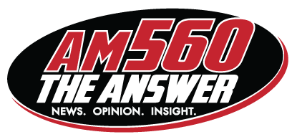 | 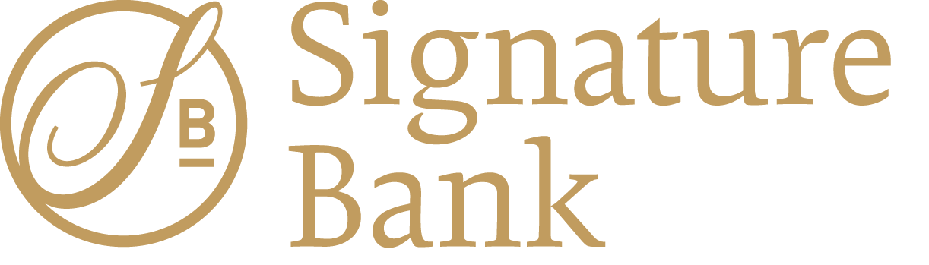

AM 560 The Answer Awards Marketing Campaign
to Business Boost Contest Winner

CHICAGO — AM 560 The Answer announced today that Neennu Gupta, owner of Bottle & Bottega in Park Ridge, Illinois, was the winner of the station’s Business Boost contest, sponsored by Signature Bank. Gupta and her small business will receive a marketing campaign from AM 560 valued at $75,000 over the course of the next year.
“We’re excited to award this wonderful prize to such a deserving small business,” said Jeff Reisman, vice president and general manager of AM 560 The Answer. “Neennu represents the best of small business owners. She’s worked hard and persevered to keep her business afloat during challenging times. We look forward to working with her in the year to come to see how she continues to grow her business.”
“This radio marketing campaign will put us in front of people to let them know that we’re open and that we’re taking all precautions to keep you and your family safe. We want them to come in and have fun,” Gupta said, during an interview on AM 560’s Chicago’s Morning Answer with Dan Proft and Amy Jacobson. “I am so, so grateful to be able to promote my business and let people know what we have to offer at Bottle & Bottega.”
“Signature Bank is happy to support the Business Boost program as part of our partnership with AM 560,” said Kevin P. Bastuga, co-founder and executive vice president of Signature Bank. “The goal of this program was to provide a local business with access to advertising and promotional support intended to help grow their business and to thrive in an ever-changing marketplace. This promotion was consistent with Signature Bank’s overall mission to support local businesses in the communities they serve during a time when businesses really need their local banking community championing them.”
Gupta was one of more than forty local small businesses who submitted entries into the contest, which ran from June through September. Contestants submitted entries explaining how their businesses were impacted during the COVID-19 pandemic, how they managed their business through the challenges of the pandemic, and why they deserved to win the marketing campaign. A panel of judges from AM 560 and Signature Bank selected the top five finalists who then submitted videos telling their story. AM 560 listeners were asked to vote for the business they believed should win the grand prize.
Bottle & Bottega is a wine and paint studio, located at 424 W Touhy Ave in Park Ridge, Illinois.

About AM 560 The Answer
AM 560 The Answer is owned and operated by the Salem Media Group, America’s leading multimedia company specializing in Christian and conservative content, with media properties comprising radio, digital media and book and newsletter publishing. Each day Salem serves a loyal and dedicated audience of listeners and readers numbering in the millions nationally. With its unique programming focus, Salem provides compelling content, fresh commentary, and relevant information from some of the most respected figures across the Christian and conservative media landscape. Learn more about Salem Media Group, Inc. at www.salemmedia.com.

About Signature Bank
Signature Bank is an award-winning, relationship-based commercial bank wholly owned by Signature Bancorporation, Inc., a privately funded, locally owned bank holding company founded in 2006. Headquartered in Rosemont, IL, Signature Bank provides accessible, strategic, and highly individualized commercial banking services to closely held companies, as well as full-service retail banking capabilities. Technology driven and well-capitalized, Signature Bank is currently the fastest growing, independently owned business bank in the Chicagoland area. Visit Signature Bank online at www.signaturebank.bank.
###

CONTACT: Jeff Reisman  847-472--8921  jreisman@salemeradiochicago.com | Elena Angelos  312-386-6908  eangelos@signaturebank.bank

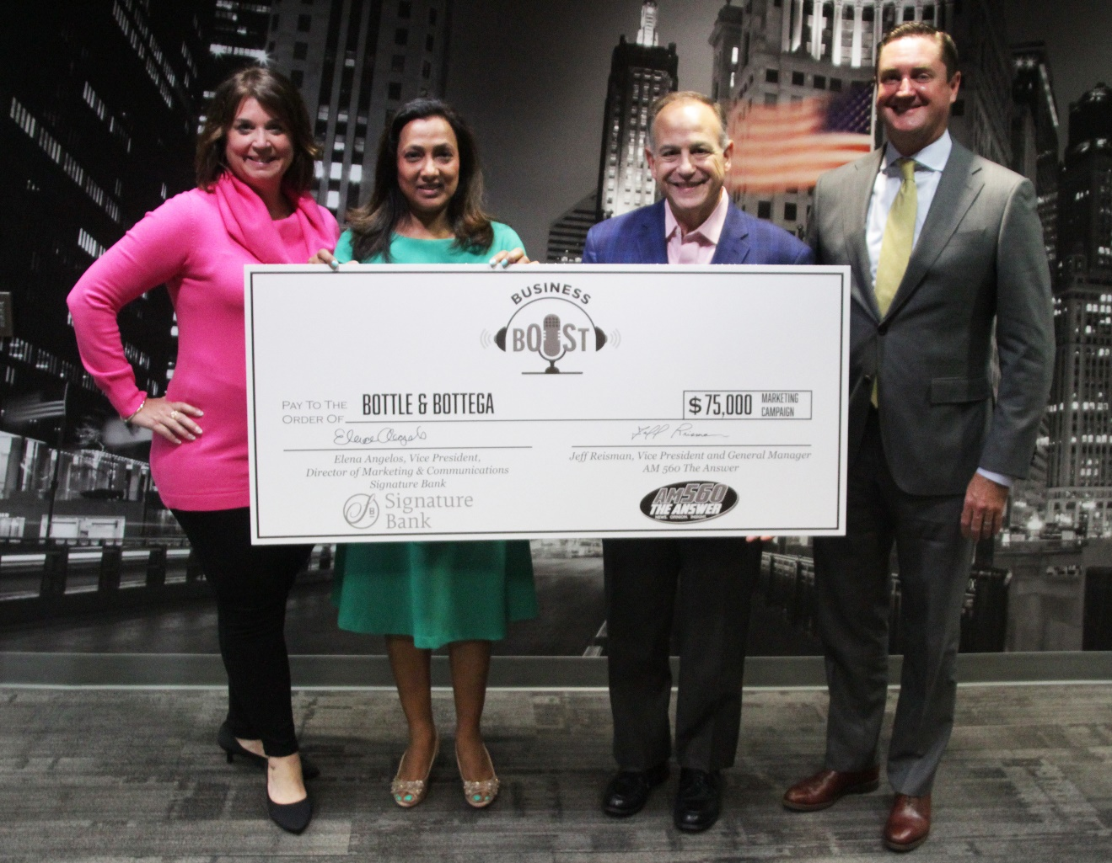
(Left to right), Elena Angelos, vice president, director of marketing & communications for Signature Bank; Neennu Gupta, owner of Bottle & Bottega of Park Ridge; Jeff Reisman, vice president and general manager of AM 560 The Answer; and Kevin Bastuga, co-founder and executive vice president of Signature Bank.

